Introduction to the Eden energy display on my website:
This is a pellet burner of about one million btu per hour output that has been in development for ten years. It is the brain child of Jim Geselle who was first operating out of Goshen, Indiana as Abundant Energy Works and is now out of Mishawaka, Indiana with the new name Eden Energy. As you can see there is a slight religious tinge to this organization.
The genius of this burner unit is that it is self-cleaning of ash and clinker and also it is self-igniting after the initial warm-up. Fuel is carefully auger fed and thus output heat can be easily modulated.
The initial design was to put a refrigerator-sized unit in every house garage to provide heat and hot water for the house. The next idea was to use the heat to make steam and a few kw of electricity while heating the house as long as there was a fire. This is co-generation. Now the design heating capacity has gone up an order of magnitude and the proposed market has changed to agricultural usage. At first blush it appears that the burner design is completely scalable.
The advantage of this burner is fuel cost. Pellets started out being made from by-product sawdust, then lawn and animal bedding material, and then candy wrappers and other plastic chips. Now the unit can burn non-pelletized material such as chopped up corn stover or wood chips, meaning lower energy input into the fuel. The original purpose of pelletizing things is to make them more compact for higher density for transportation and storage and for easy auger handling so they can be both stored and moved around like grain.
The world of possibilities opens up for heat once there is cheap available fuel and a clean burner that does not require human attention. I, of course, think that the Rankine Cycle is the next step. – Tom Kimmel
Website: http://www.edenenergyworks.com/
Recovery system below: http://www.edenenergyworks.com/technology/

Eden Energy is Resource Recovery



RESOURCE RECOVERY... A SIMPLE CONCEPT, YET PROFOUND IN IT'S EFFECT ON OUR WORLD.

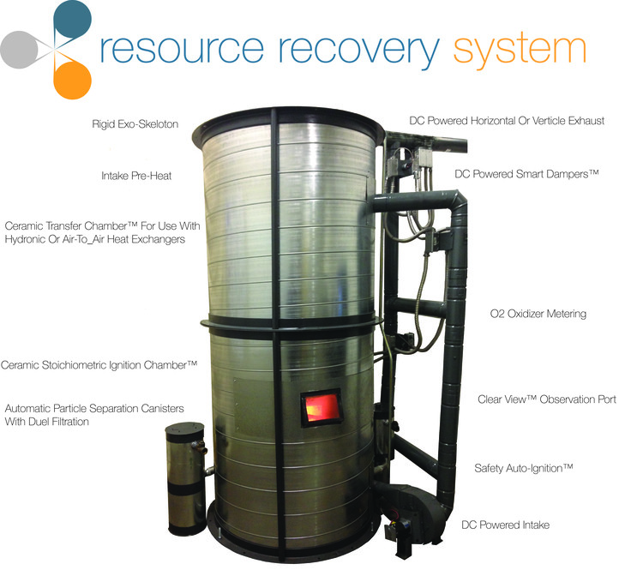

The Resource Recovery System is a combination of advanced materials and engineering that takes waste and converts it to usable energy. It starts with stacked inner shells of non-cementitious colloidal silica ceramic that is resistant to both corrosive materials and thermal shock. Inside the first shell is the Stoichiometric Ignition ChamberTM that perfects the combustion process. The Fire Tetrahedron is continuously monitored, opening and closing the DC powered Smart DampersTM to allow for oxidizer metering or recirculation as needed. The second is the Transfer ChamberTM where the reclaimed energy is transferred to usable power. The fuel is metered in through Double Gated Safety Doors, a system that has redundant safety features. The elemental residue left over is automatically removed through the Automatic Particle Separator to be used or profitably marketed. Though the Resource Recovery System is designed to run continuously, start up is safe and easy with the Safety Auto Ignition.

